Sustainability as a driver for innovation

Fabrice Gallou

Novartis Distinguished Scientist
Chemical Development, Novartis
Novartis Campus, 4056 Basel - Switzerland
fabrice.gallou@novartis.com

During our evaluation of the potential of surfactant technology, we have identified a variety of straightforward and highly advantageous transformations and applied them successfully on-scale on various chemo and biocatalytic transformations. Implementation of the technology typically results into significant benefits across our entire portfolio, not just from an environmental standpoint but also from an economic and productivity perspective. To name a few: reduction of organic solvent consumption, water use and cycle time, milder reaction conditions, improved yields and selectivities,² much greener footprint,³ which all contribute to improved process performance and lower manufacturing costs.
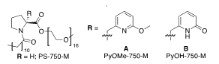 | 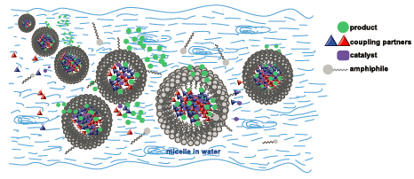
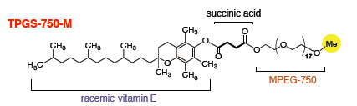
Modern non-ionic surfactants for micellar catalysis in water.
These surfactant mediated reactions can be up-scaled in the already existing multi-purpose facilities of pharmaceutical or chemical organizations, using a catalytic amount of a combination of a non-ionic designer surfactant (e.g. TPGS-750-M, PS-750-M and derivatives) in water, and a well-chosen organic co-solvent instead of traditional and undesirable organic solvents. We now start gaining insight onto the physical phenomena involved and the role of the various components of the reactions and utilize this know-how to design even better catalytic systems.⁴

ACS Sustain. Chem. Eng. 2022, 10, 5148. Chem. Catal. 2023, 3, 100485. Chimia 2020, 74, 538. Chem. Rev. 2023, 123, 5263. 2 Green Chem. 2016, 18, 14. Curr. Opin. Green Sust. Chem. 2017, 7, 13. 3 Chimia 2019, 73, 9, A681. Org. Process Res. Dev. 2021, 25, 900. ⁴ Curr. Opin. Colloids and Interface Sci. 2021, 56, 101506. J. Colloid Interface Sci. 2022, 628, 819; Chem. Catalysis 2024, 4, 101146; Chem. Sci., 2023, 14, 12049.

