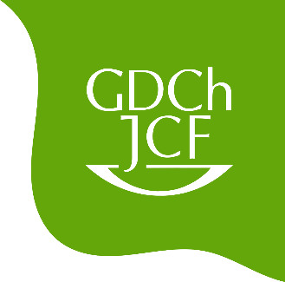

PhD Talks

In collaboration with the chemical institutes of TU Clausthal, we will provide insights into current research in Clausthal.

Lennart Arendes (ITC)
Itaconates in Radical (Co)polymerizations

Cedric Jünemann (IPC)
A Combination of a Quartz Crystal Microbalance (QCM) with an AFM Images both Friction at the Surface and Softness in the Sub-Surface Region

Mattes Plieth (IOC)
Have You Tried Switching It Off and On Again?
Fatigue in Photoswitchable Molecules

Franziska Sand (IAAC)
Influences on Picoliter-Derived Film Formation

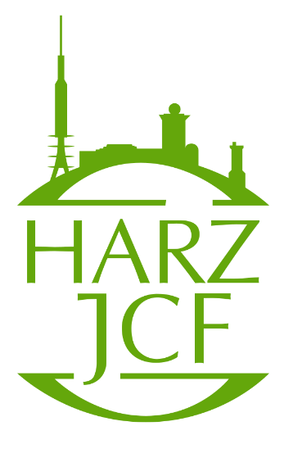
Date: July 9th at 4:15 pm
Location: Großer Physik Hörsaal
(Building C2, Room 115)
Afterwards everybody is invited to join for a barbecue.

